Process Document

Scenario: current planned price maintaining in material master(MM03)
Error:
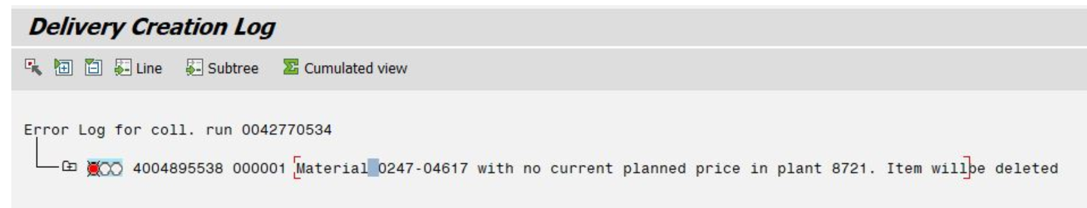
Step 1. Go to MM03 give material number and plant
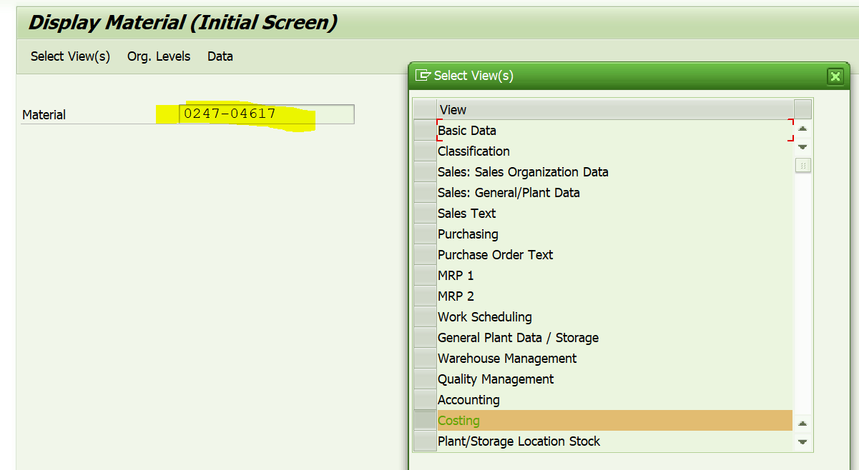

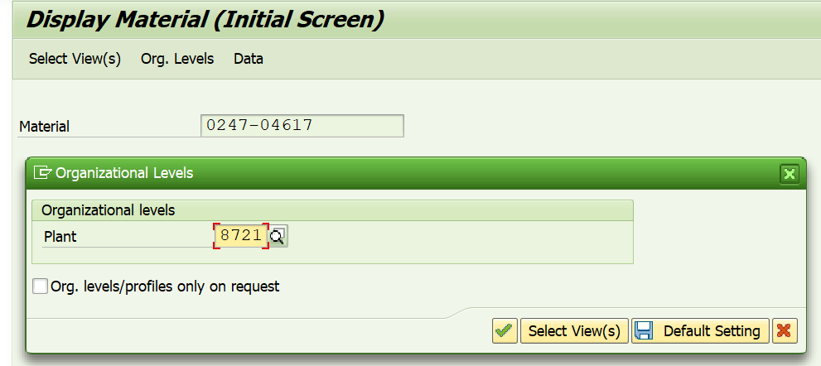
Enter

Check whether current planned price is available or not?
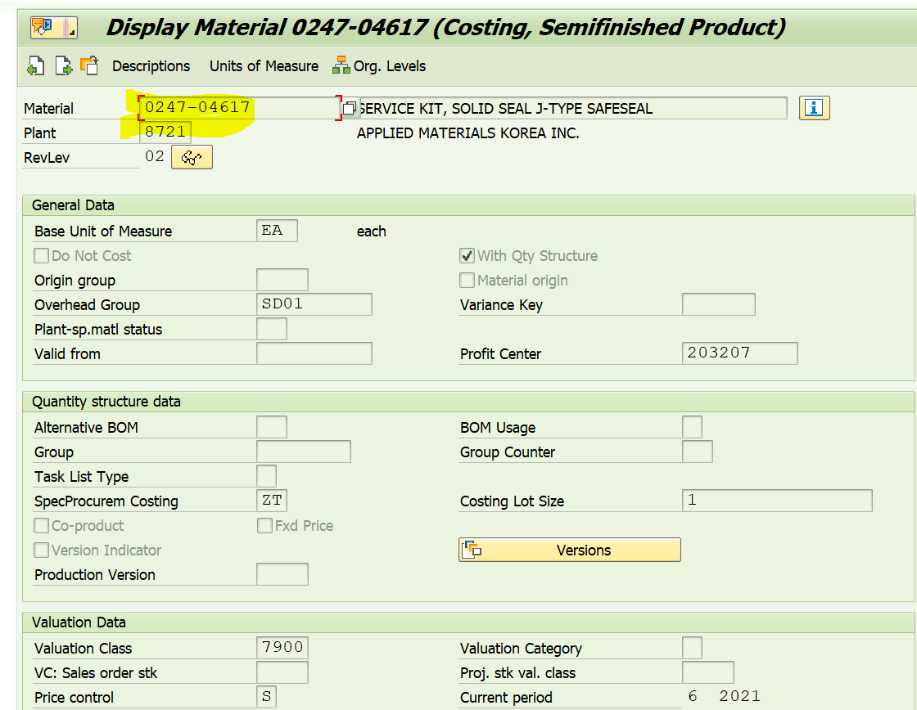
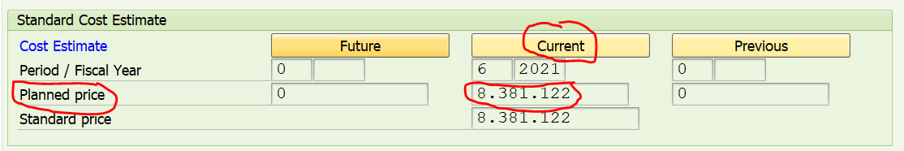
In the above scenario current planned price exists, because I maintained already, generally it should be blank
Assume it is blank then,
Step2. Check MRP 1 tab for procurement type.
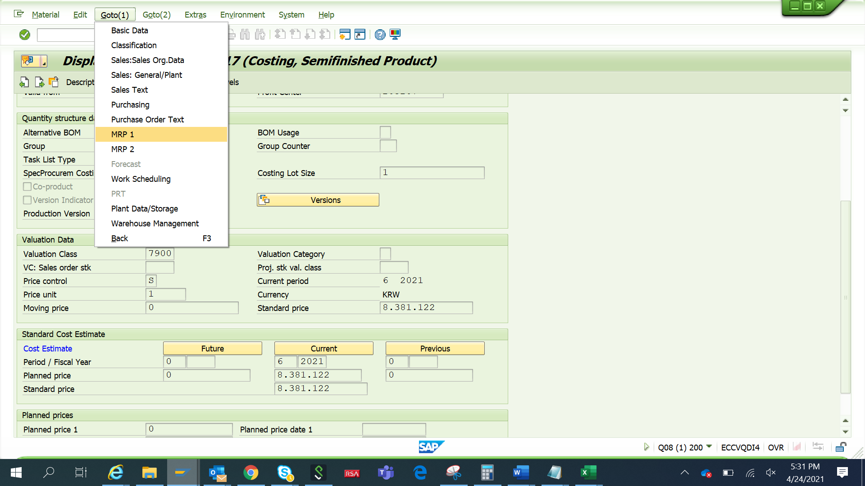
Give plant number and enter

There are 3 procurement types.
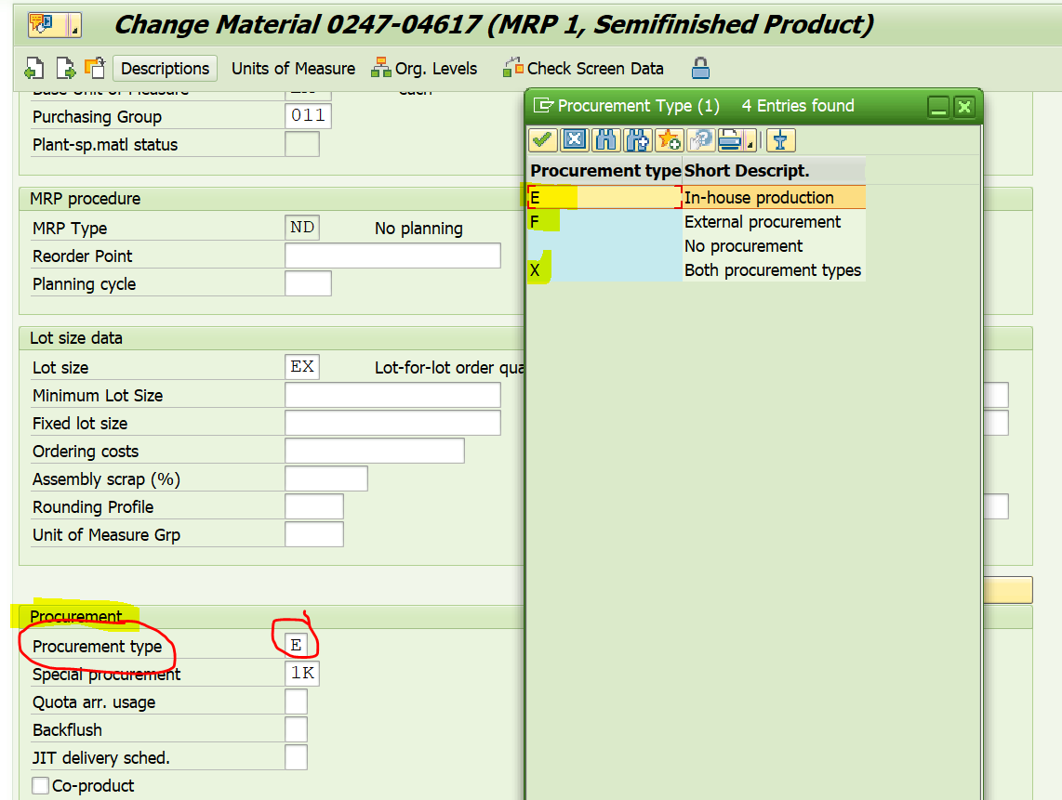
Explanation about 3 PT:
E: In house production: The particular part should be manufactured within the organization its make part, so BOM and routing is the main criteria to update current planned price.
F: external procurement(Buy Part): The particular part should buy/purchase from the vendors/outside, so purchase order/purchase info record is the main criteria to update current planned price.
X: Both PTs: the particular part either buy or make part, so BOM or PIR/PO is the main criteria to update price.

In our scenario its “E”- In-house production

Step 3: Check BOM is available if PT is “E” or Check Purchase order if PT is “F
BOM table: SE16N->MAST- standard
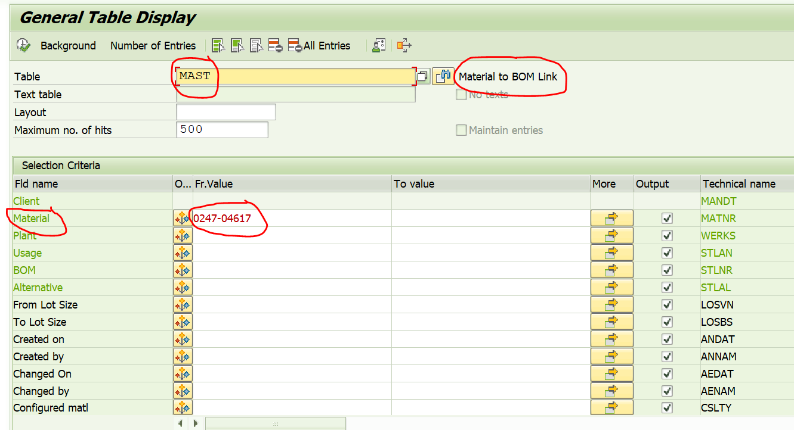
If PT is “F”, check PO
PO table: SE16N->EKPO-standard
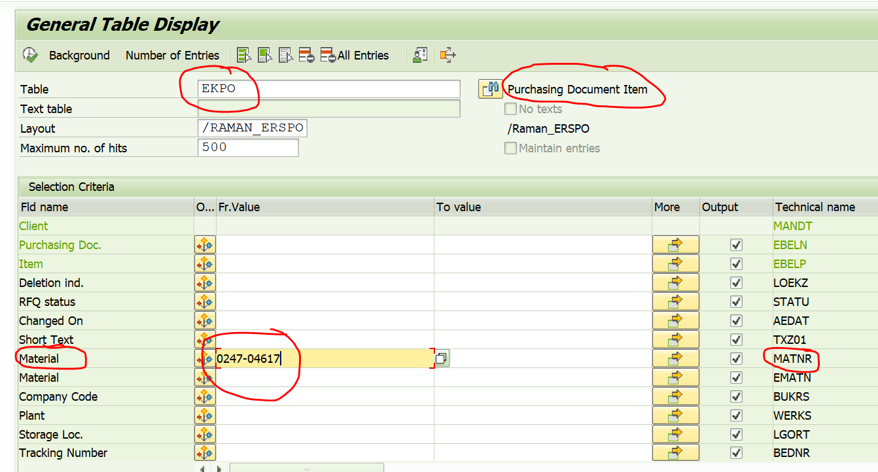
In our scenario go with BOM-MAST table
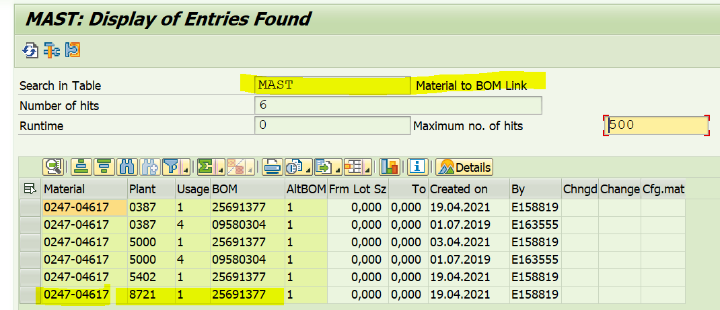
Step3: maintain current planned price
Individual costing: CK11N and CK24
Mass costing: CK40N
Let try CK11N- individual costing
Go to t code CK11N and enter the below parameters
Material ,plant and costing variant(SDL1(local currency)-AMAT specific) standard(PPC1)
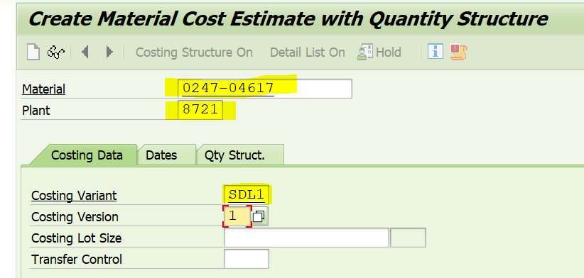
Enter
Costing Date From, Qty Structure Date and Valuation Date should be current date
Costing Date To is maximum system date eg: 31.12.9999 as below.
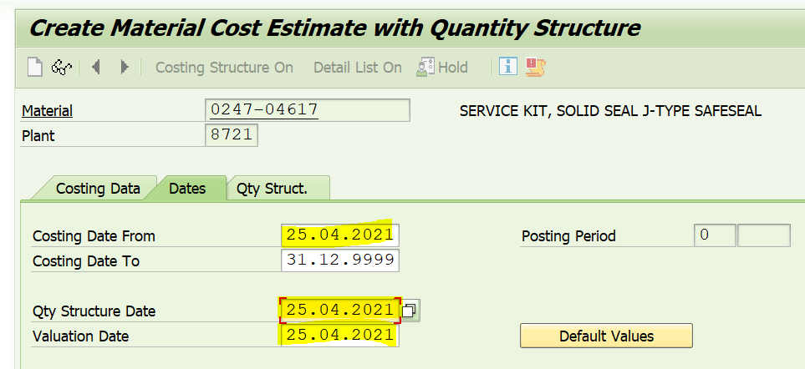

Enter
Below screen is appear
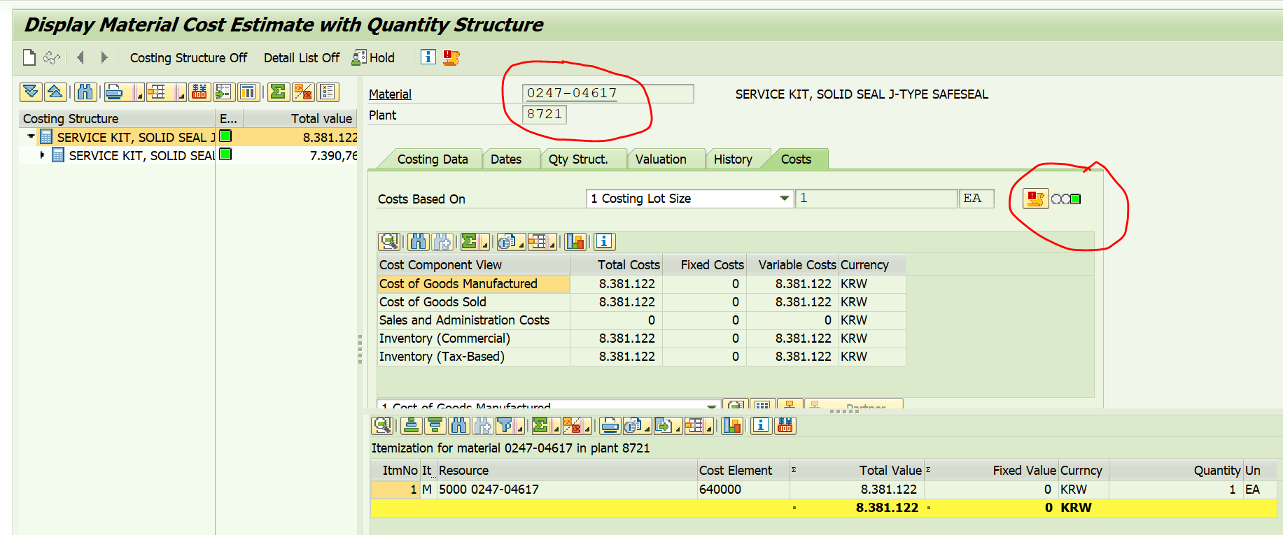
Check indicator “green” and local and group currency.
Save the screen
Come back and do the same thing for group currency
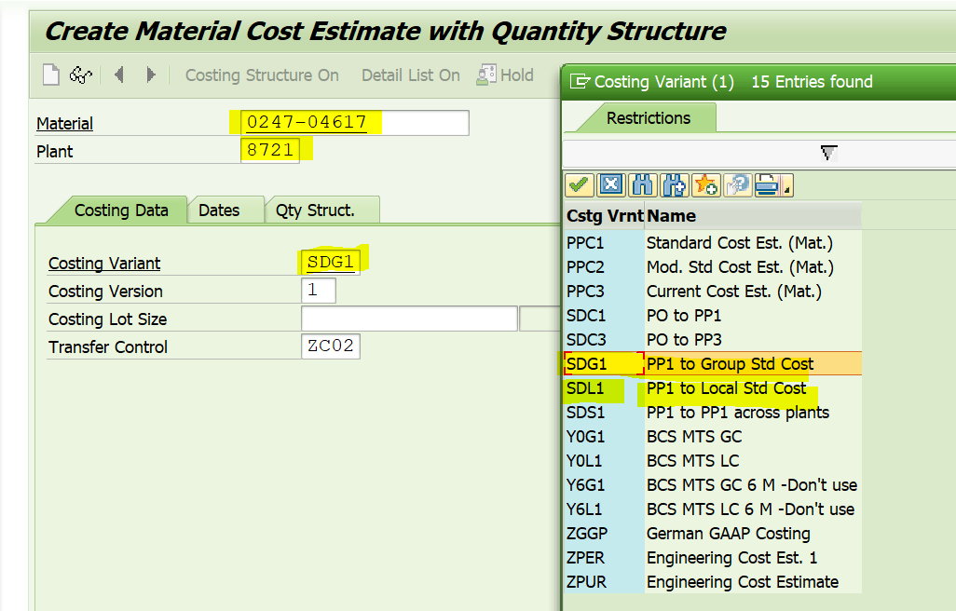
Enter
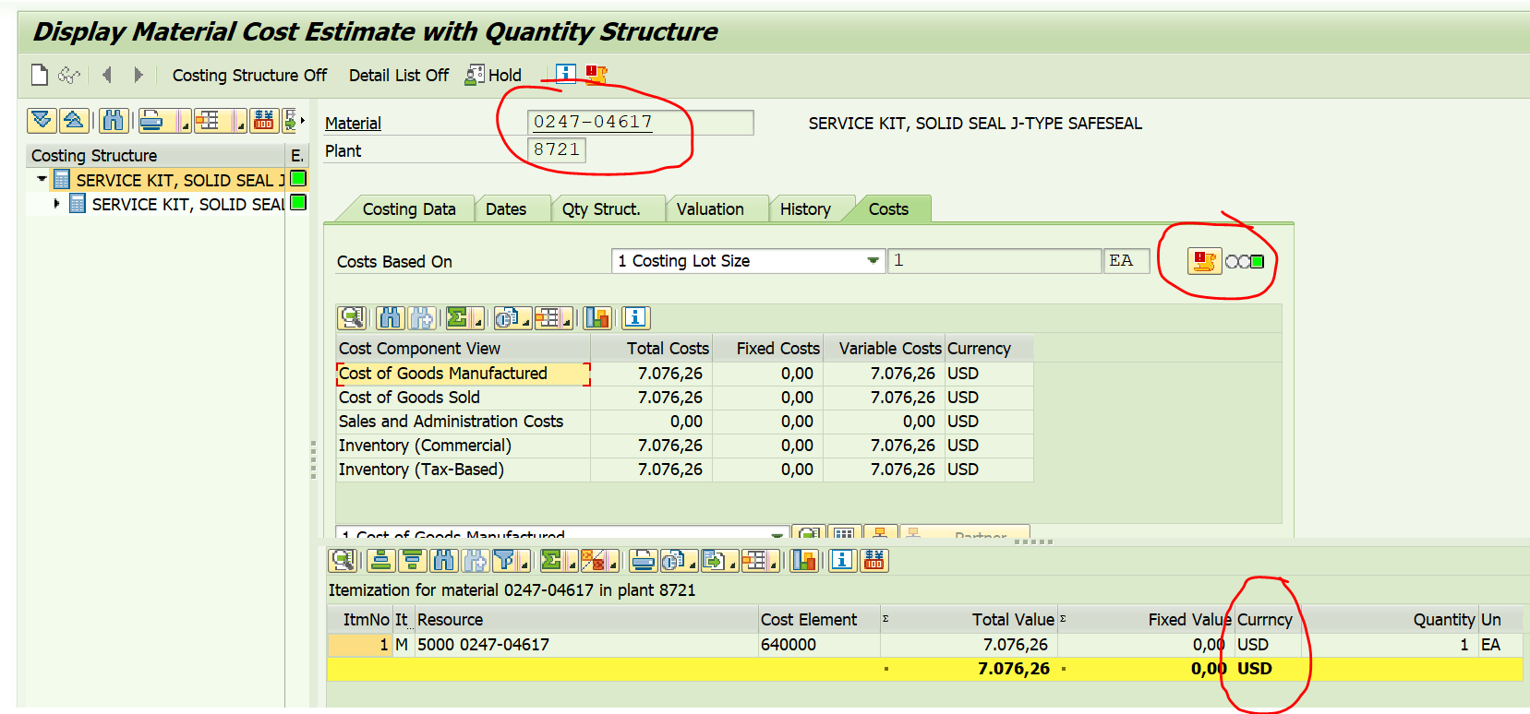
Save
Step 4.
Marking and release -t code- CK24
Enter, period/year,plant and material and execute in test run.

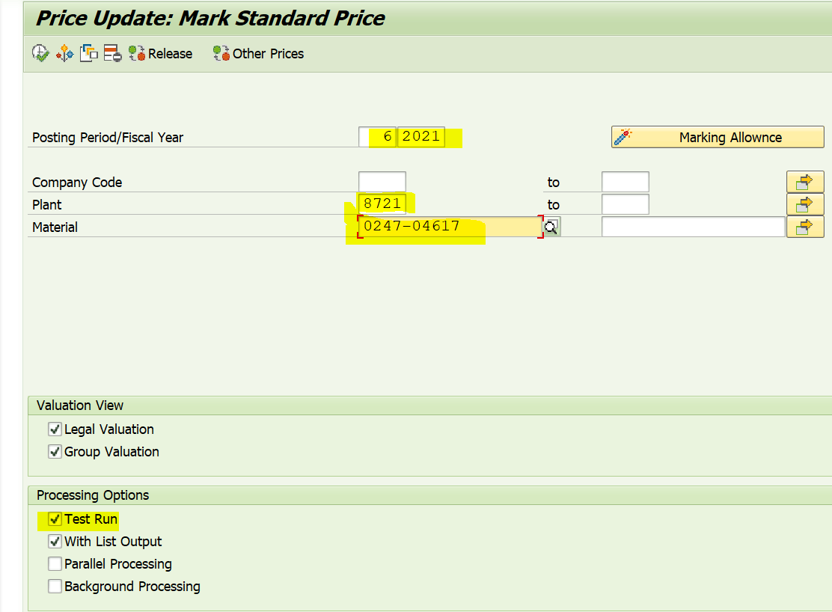
execute
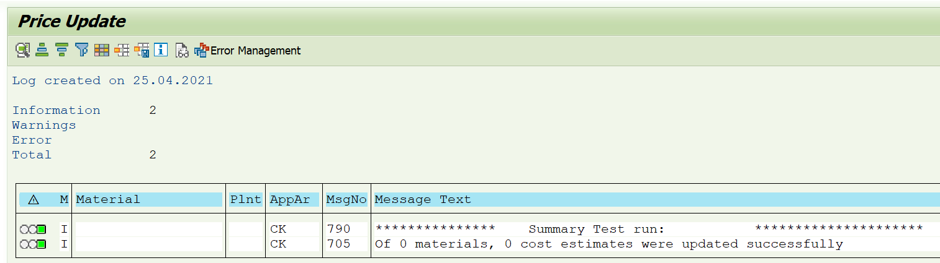
Come back and remove test run and execute
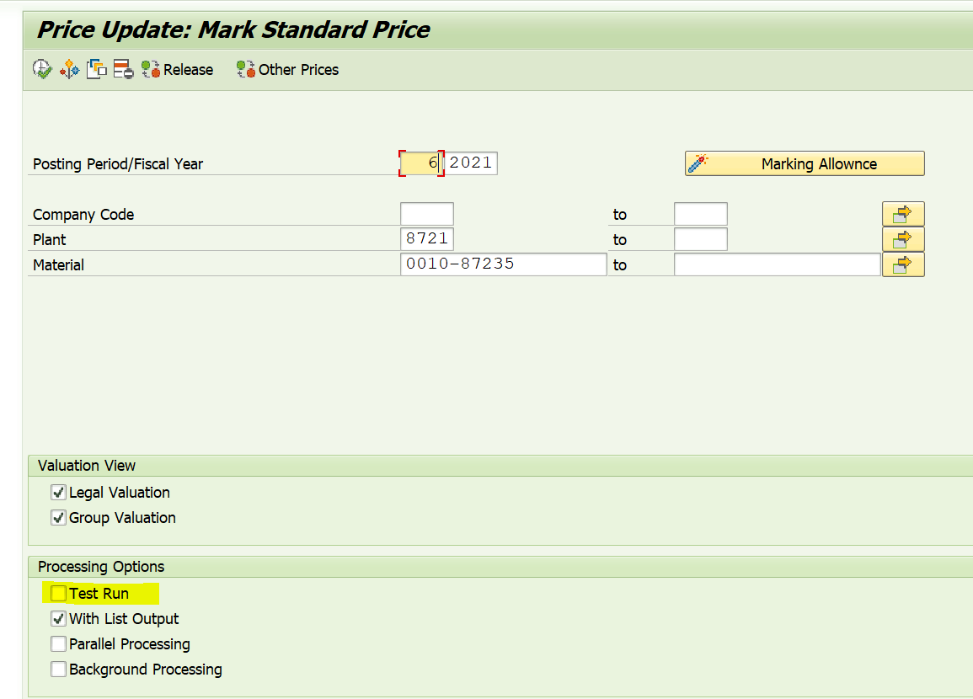
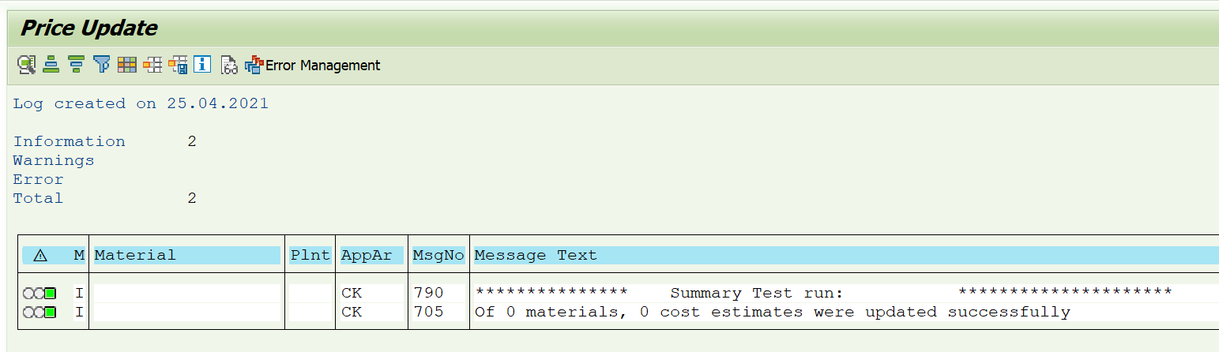

Let us do the cost update via CK40N
In incident user ask to updated missing current planned price as below
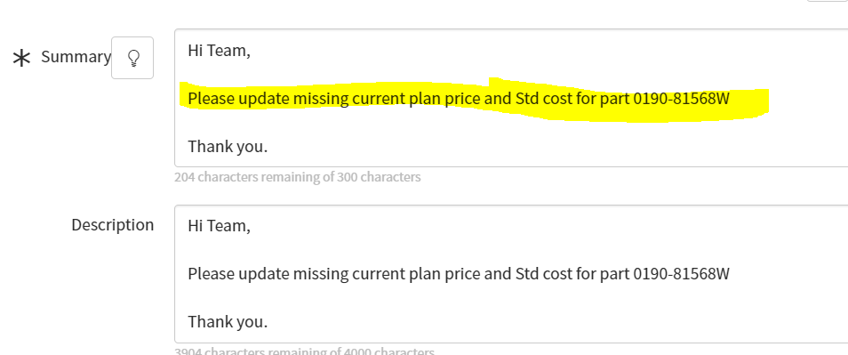

Resolution: in some plants current planned price is missing, we need to find out those plants
Go to table MBEW and select 5 fields as below
Material-MATNR
Valuation Area/plant-BWKEY
Planned price 1-ZPLP1
Current Planned Price-LPLPR
Standard price-STPRS
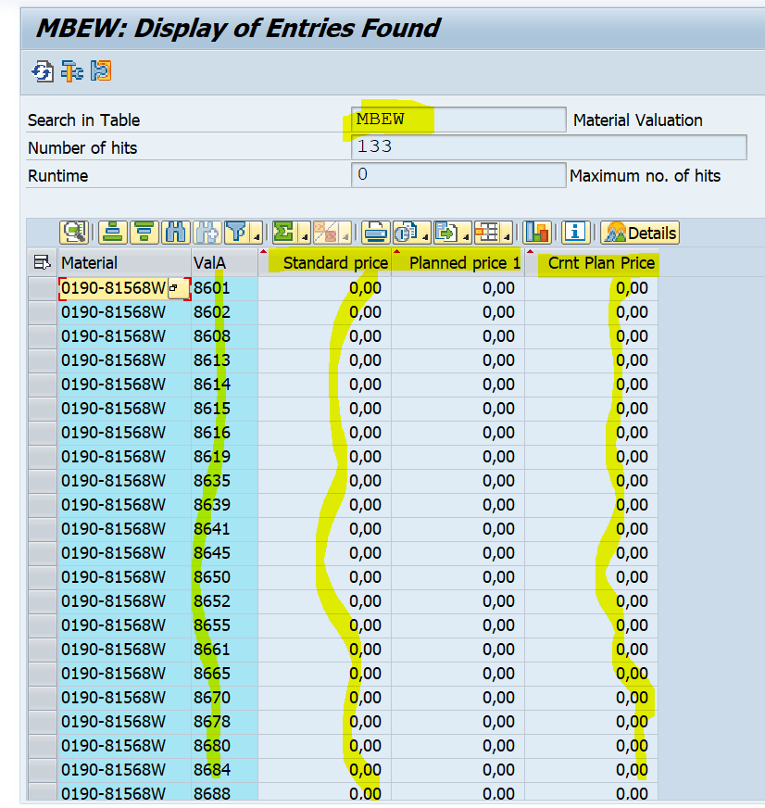
So, now we are going to update missing price in above highlighted plants

Go to CK40N
Below screen is opened
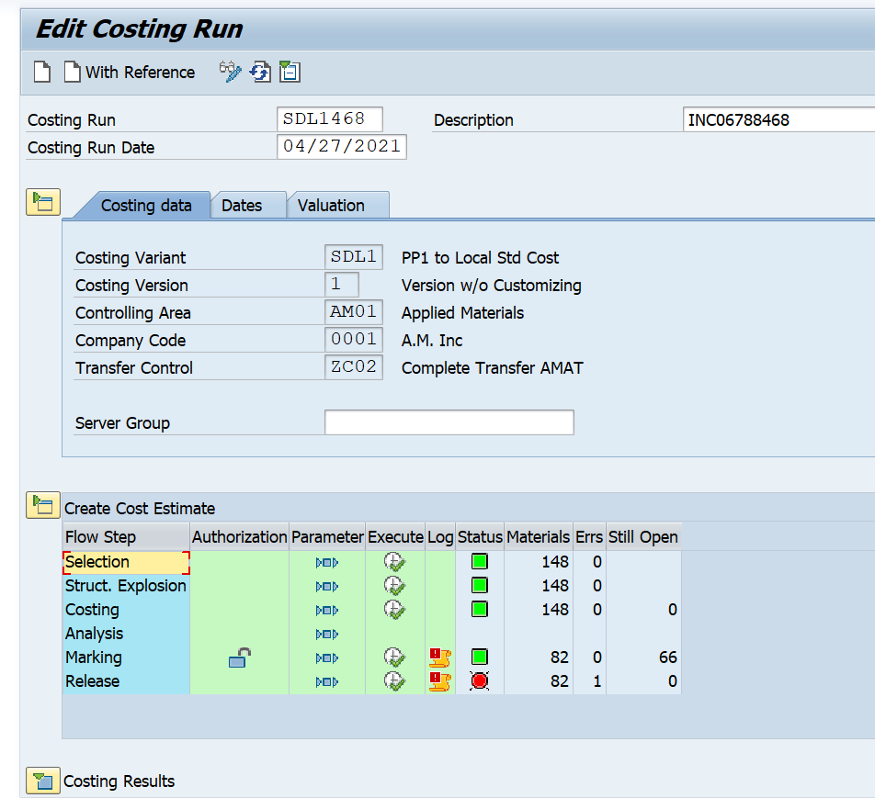

Click on create and proceed to create variant by using the following yellow highlighted parameters
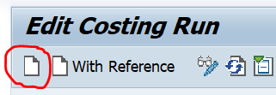
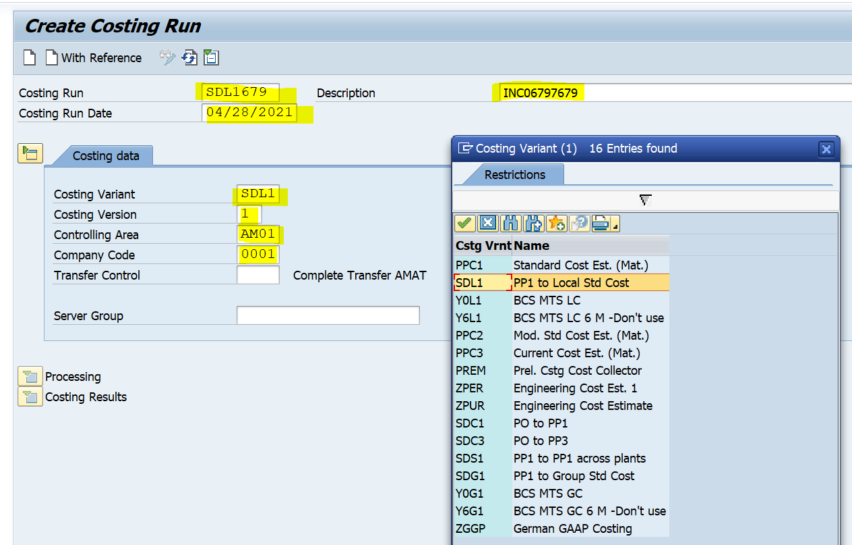
Costing Run- crate any name for eg: I created SDL1679(costing variant with last 3 number of incident)
Description: give incident number
Costing Run Date: today’s date
Costing Variant: SDL1(local currency-AMAT specific) generally PPC1-standard
Costing Version: always 1- Version w/o Customizing
Controlling Area: AM01 (AMAT specific)
Company Code: give company your code-0001

Click on save

Below screen will open with yellow highlighted message, which means variant saved.
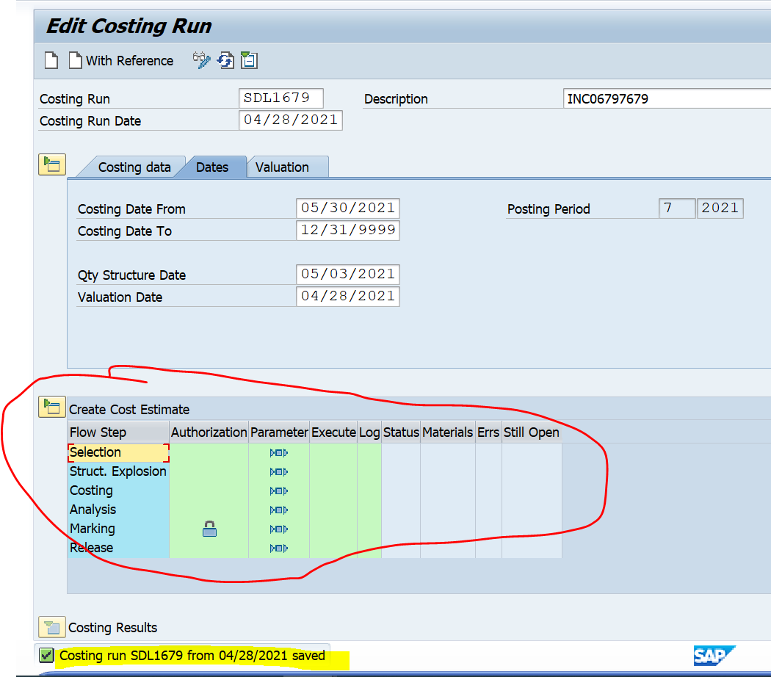
Now,
Change the date settings as below,
Costing Date From, Qty Structure Date and Valuation Date should be current date
Costing Date To is maximum system date eg: 31.12.9999 as below.
After enter dates click on enter and check the year and period also
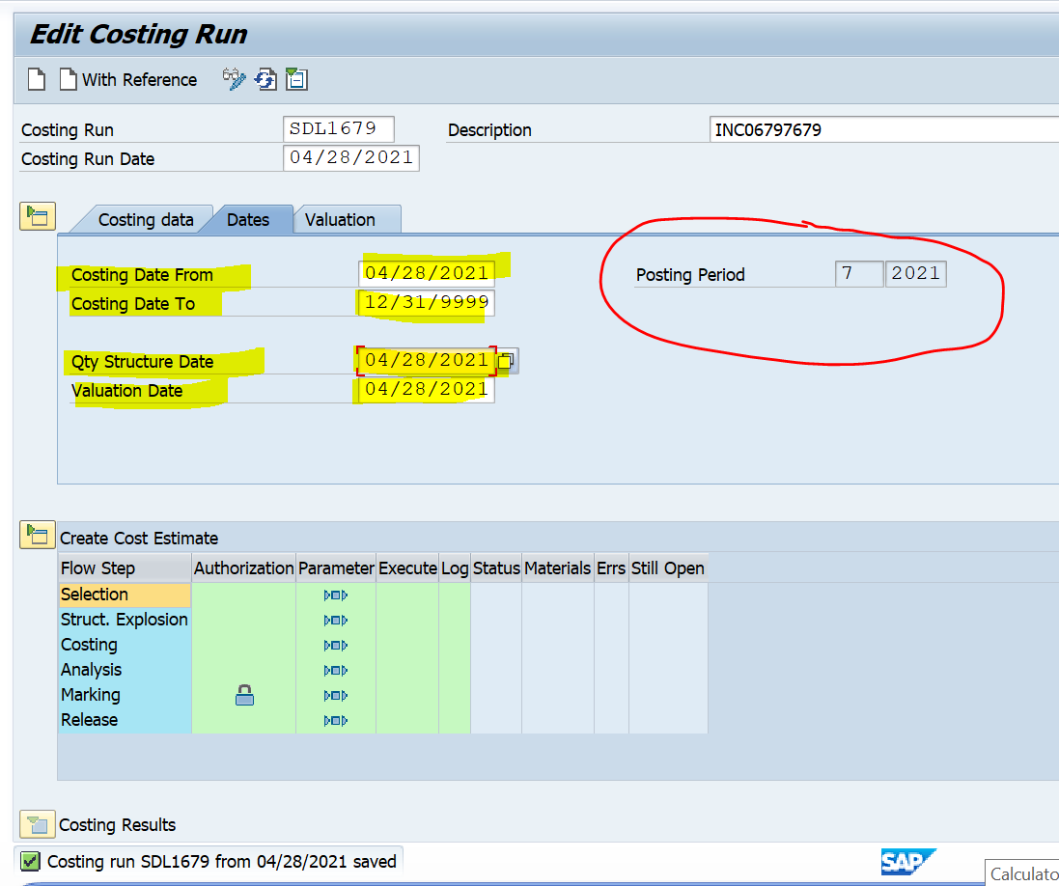
Click on save.
Now, enter the parameters as below.
1: selection-click on parameter

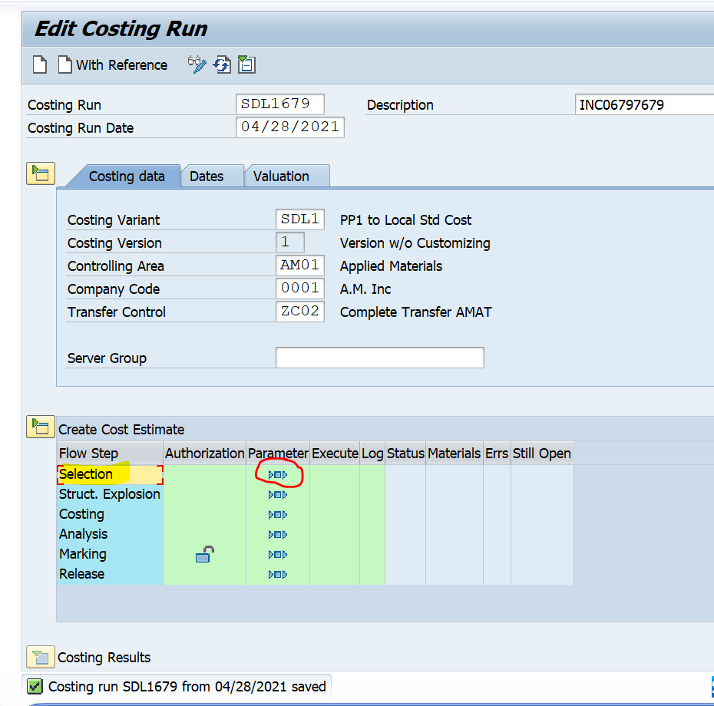
Below screen will opened
Enter the material number, click on always re cost material and unchecked background processing and save
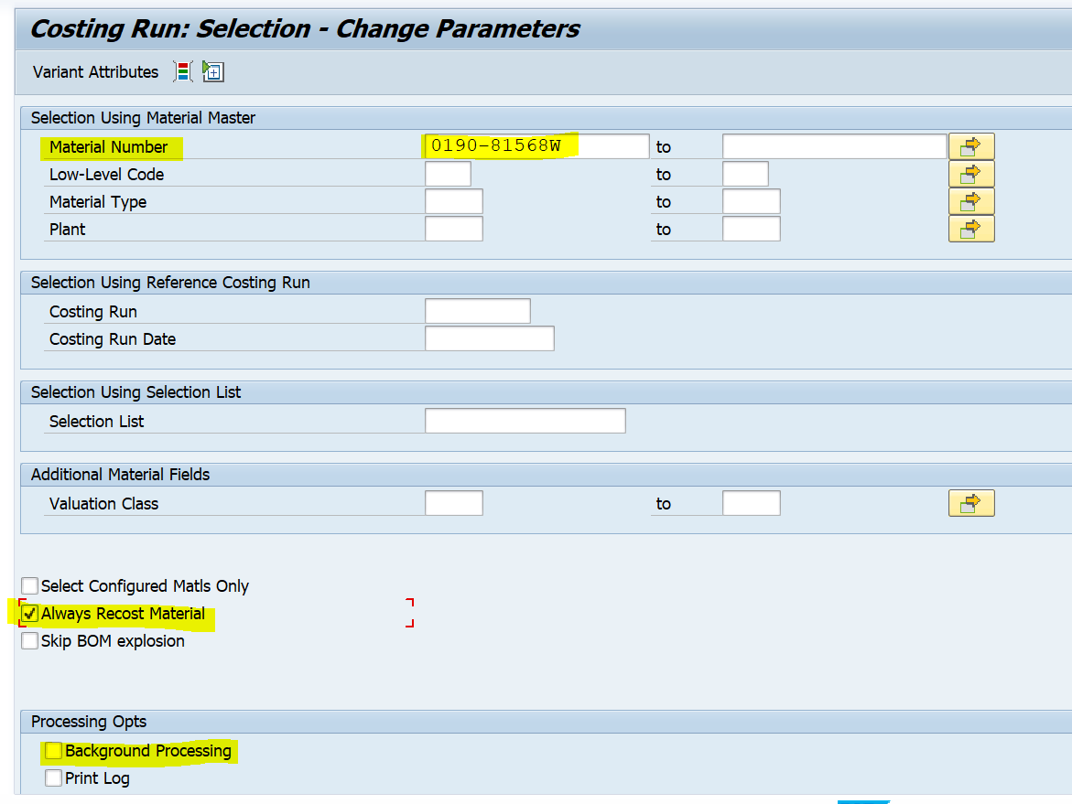
Come back and click on execute as below
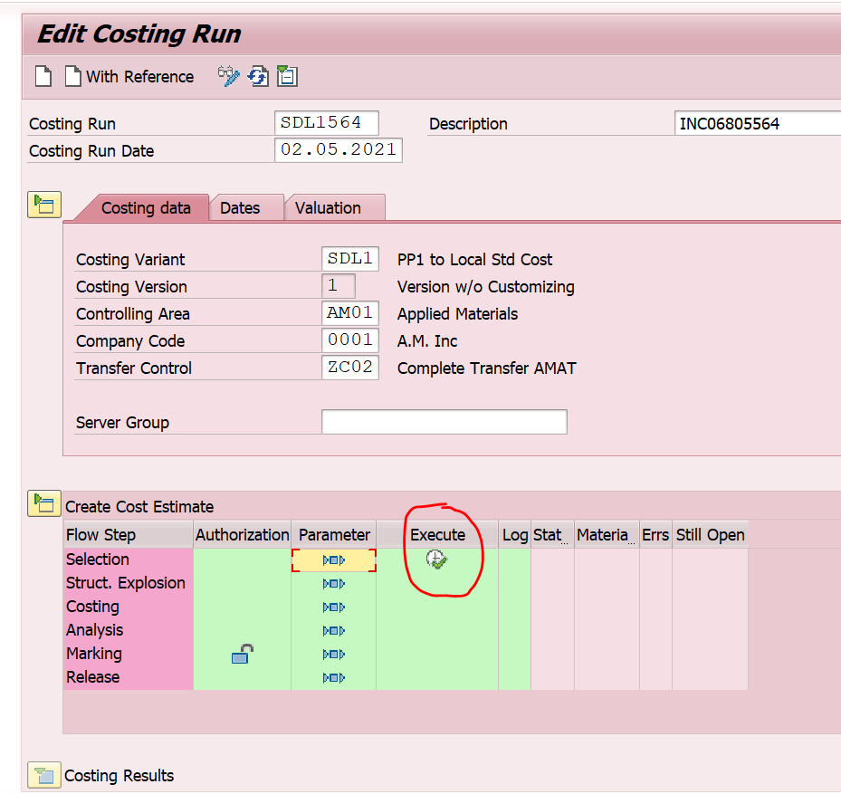
Will get below message
Step 2.
Click on structure explosion-parameter
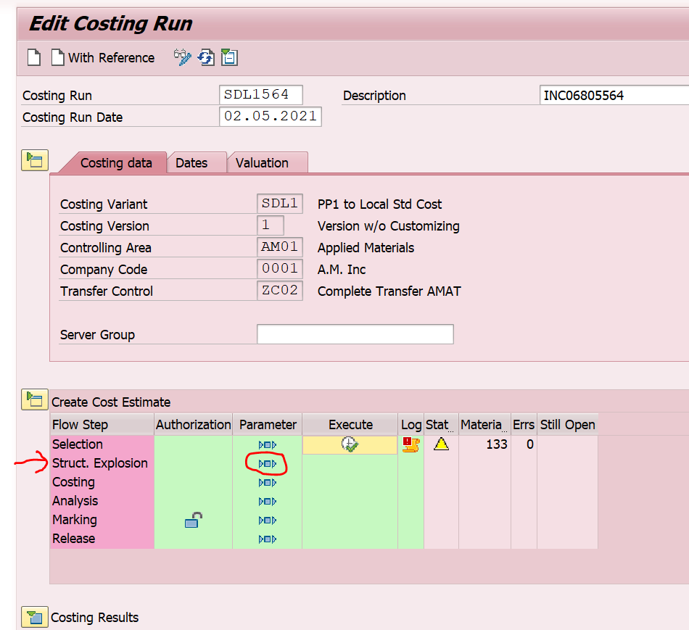
Remove background processing and save screen and come back
Click on execute as below
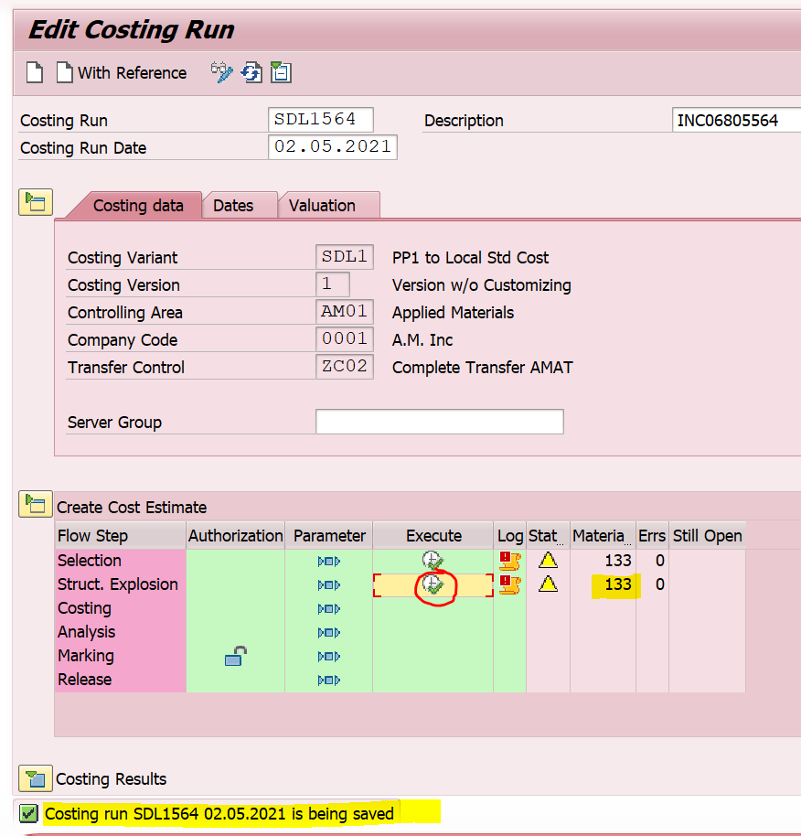

Step 3.
Click on costing-parameter and save
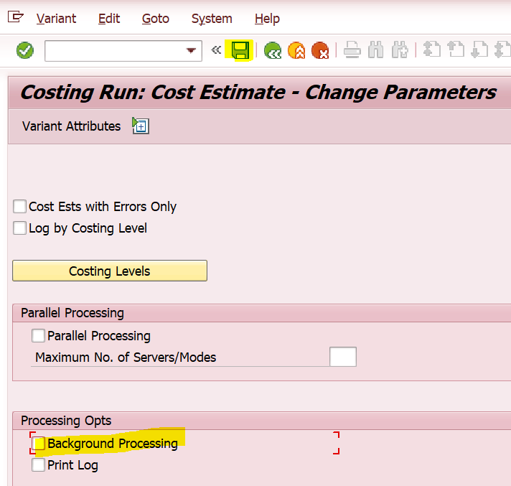
Come back and execute
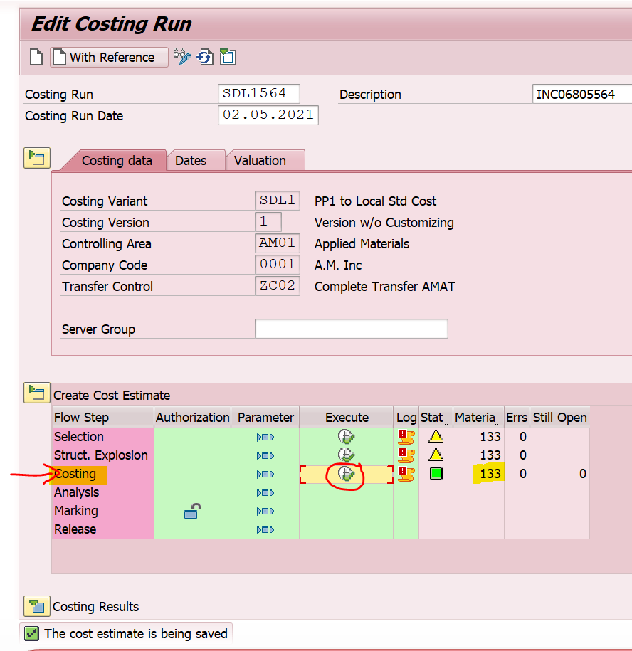

Leave the 4th step-analysis and move on to 5th step
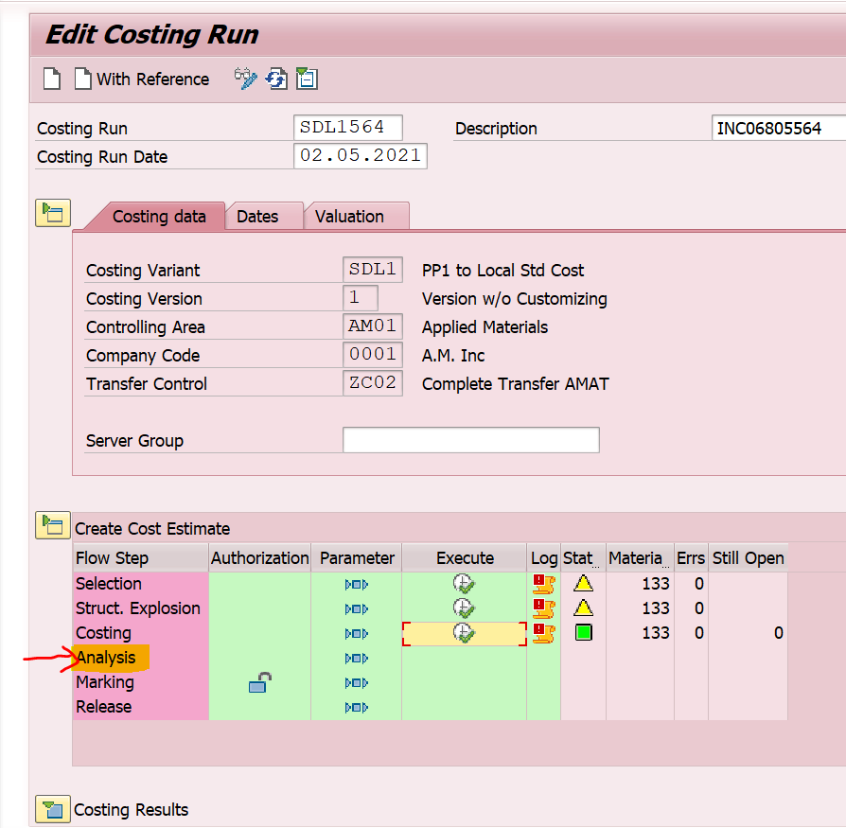

Step 5-click on marking-parameter
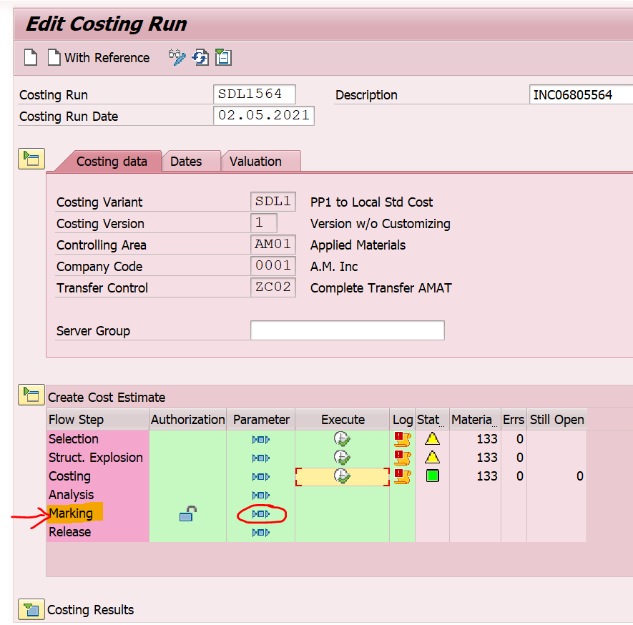
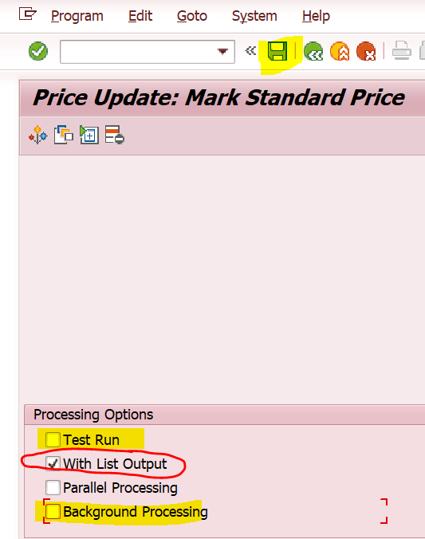
Remove test run and background processing as above and save
Come back and click on execute
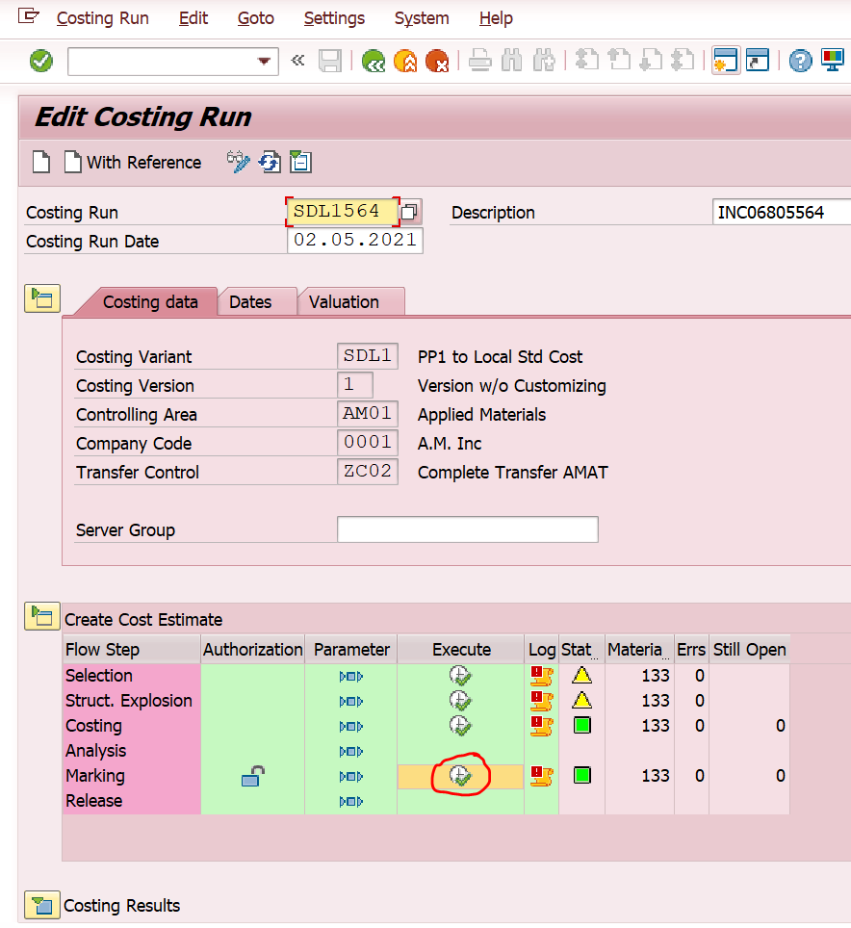
Verify the below marking prices
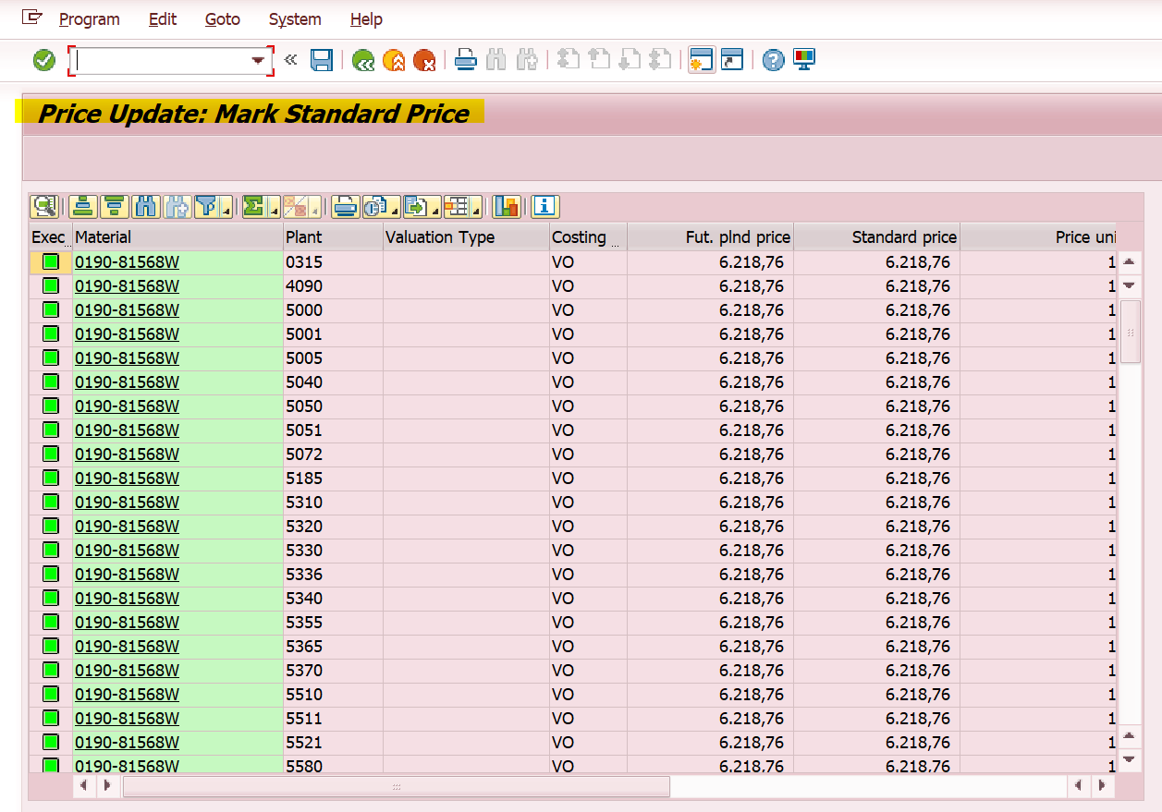
Step 6- release -parameter
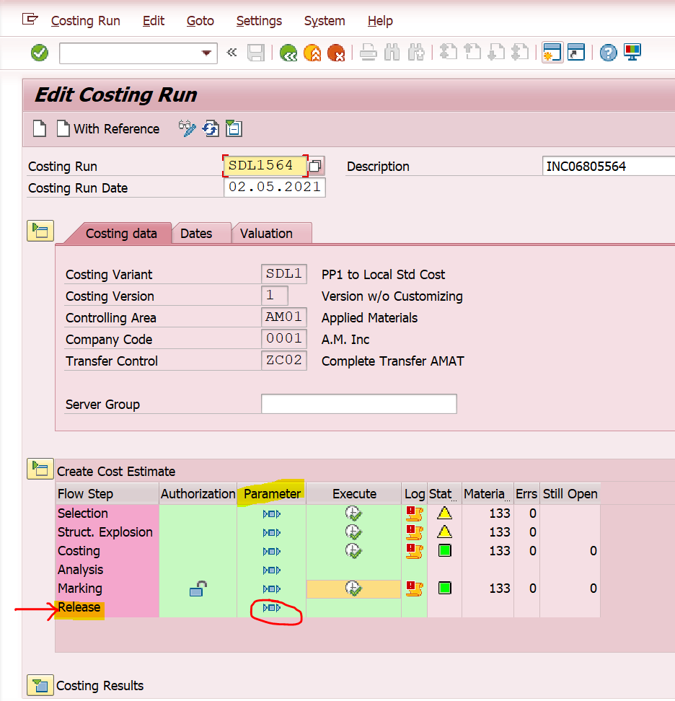
Remove test run and background processing in below screen and
save
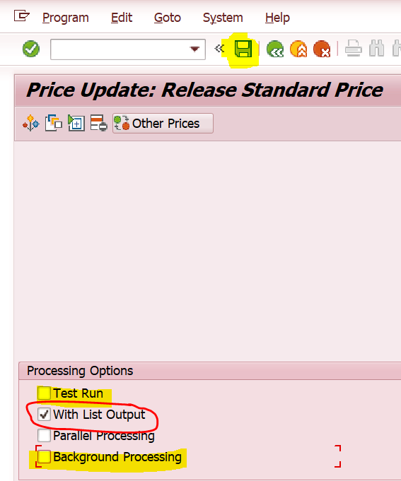
Come back and click on execute
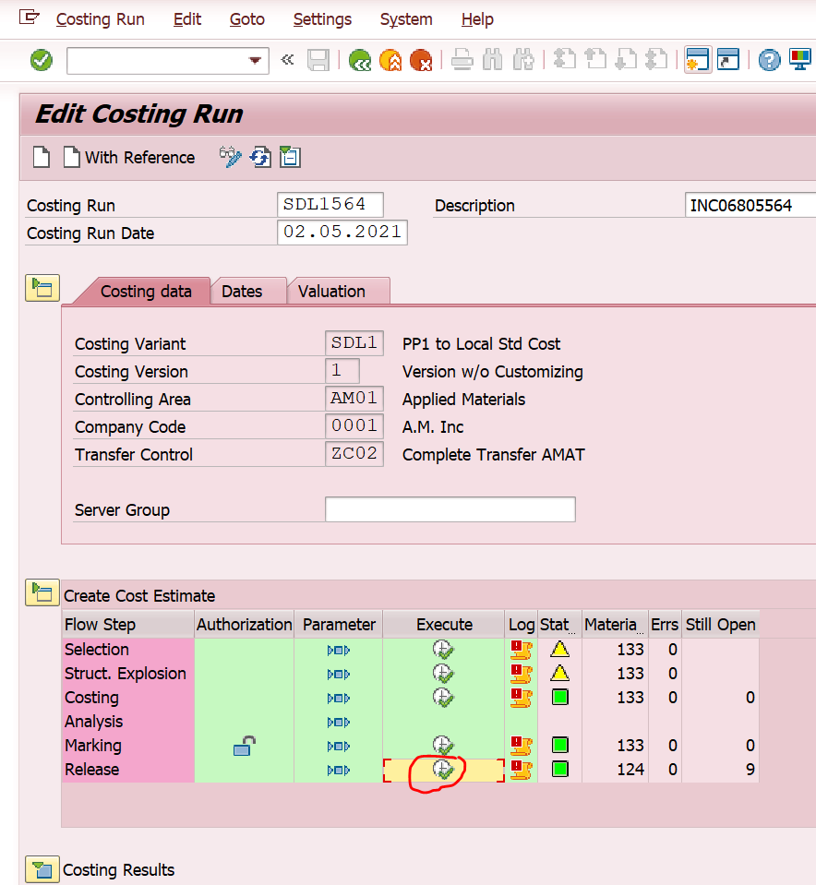

Verify the below released prices
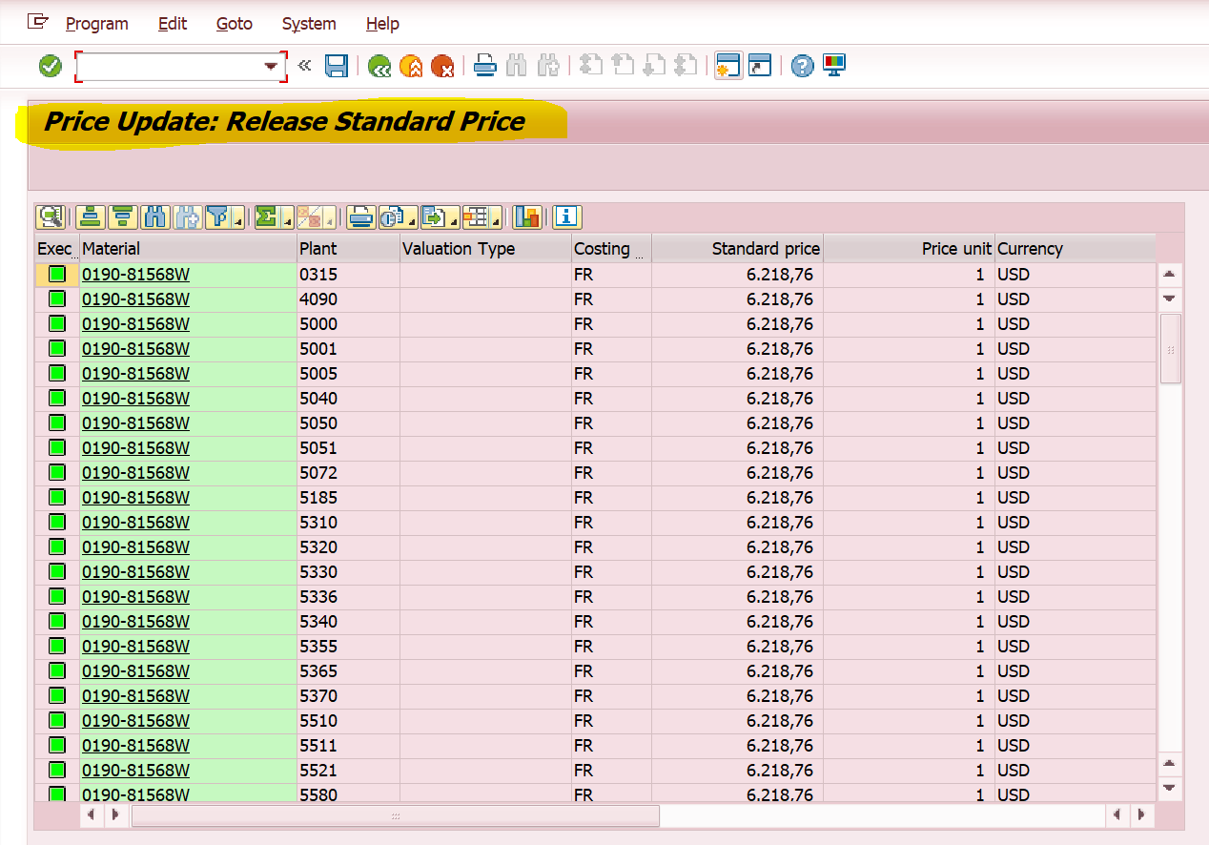
We have done with local currency, now we are going to update group currency
Costing variant- SDG1(AMAT specific)
Click one create as below
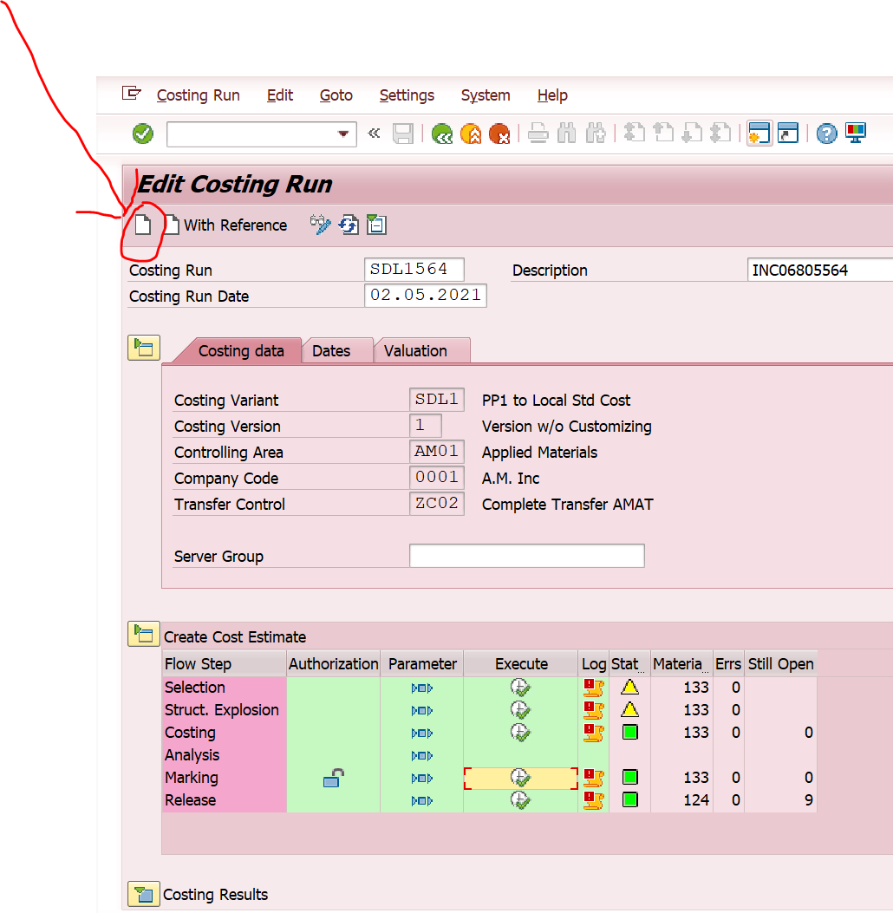
Enter below yellow highlighted parameters except company code
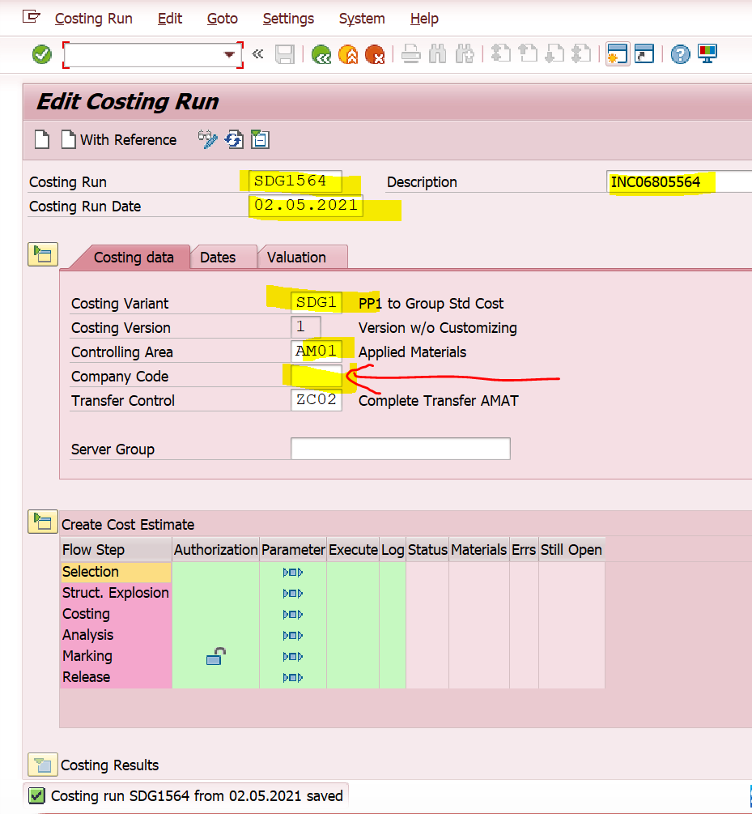
Click on save
Enter the below date parameter
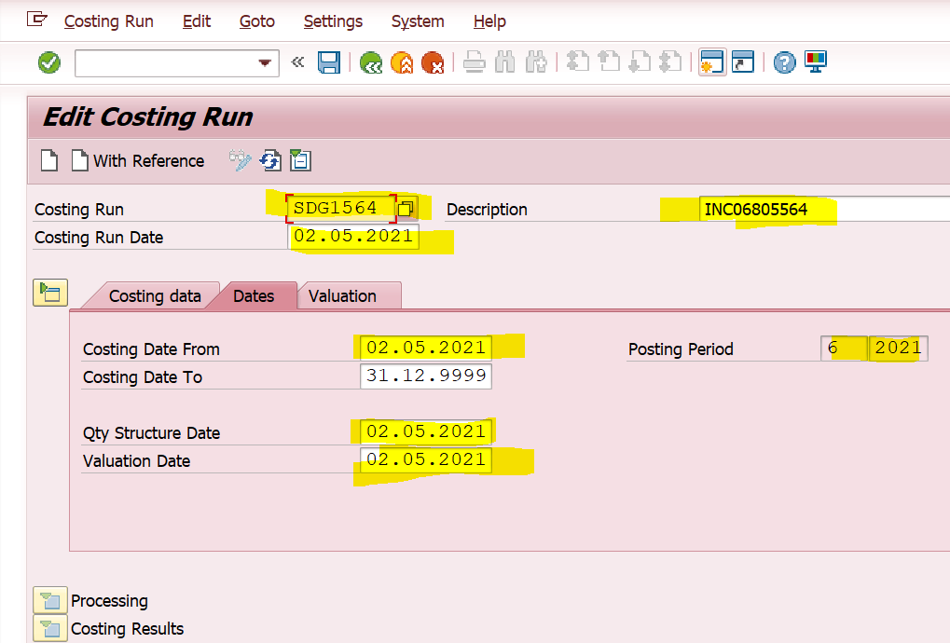
Click on save
Below screen will appear
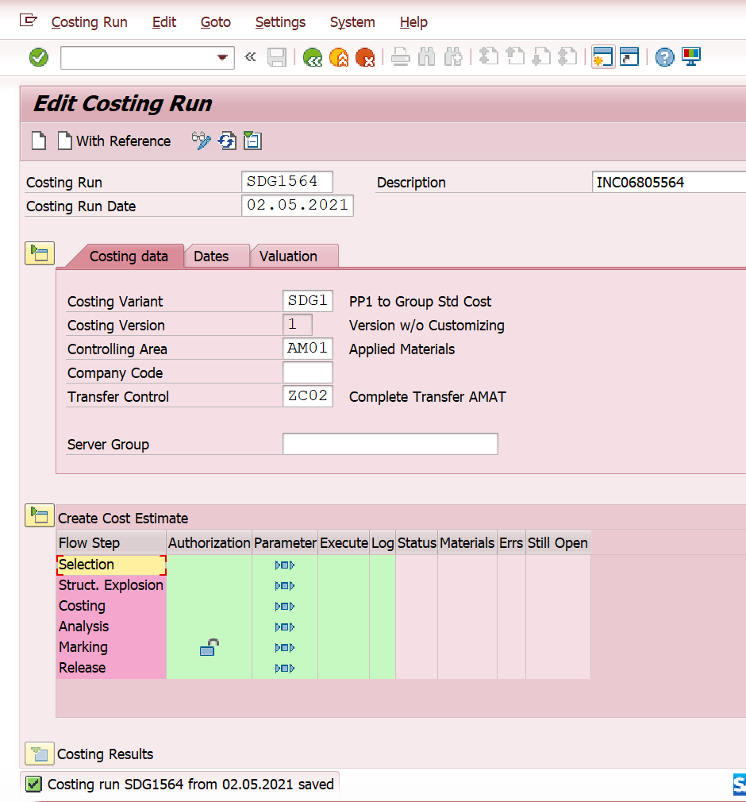

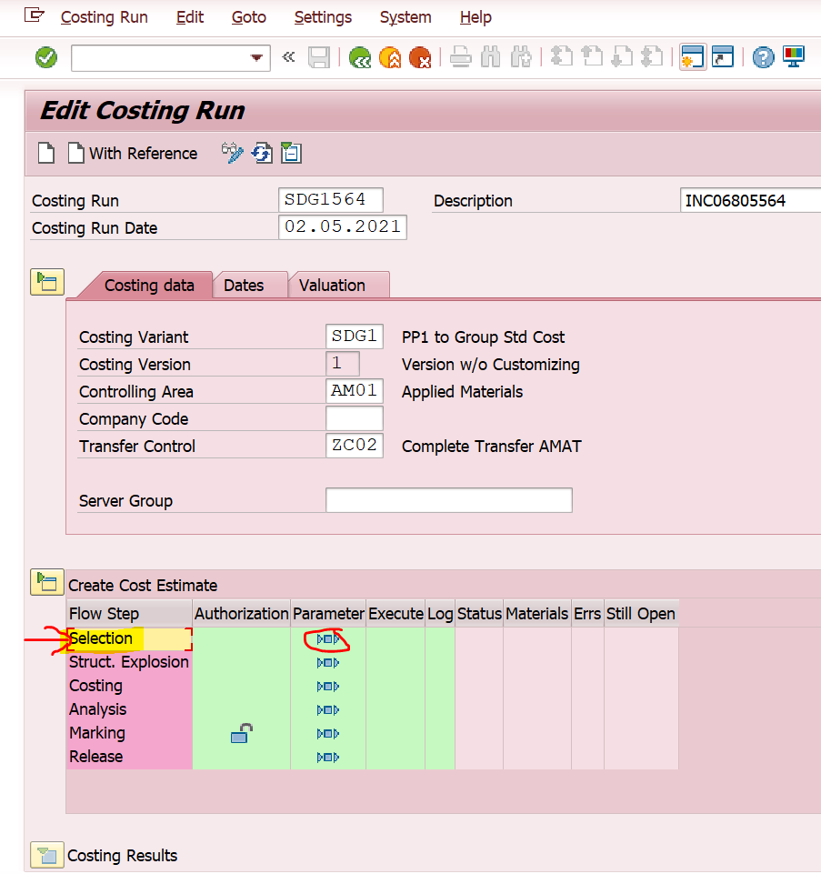
Enter the material as below and remove background processing and save
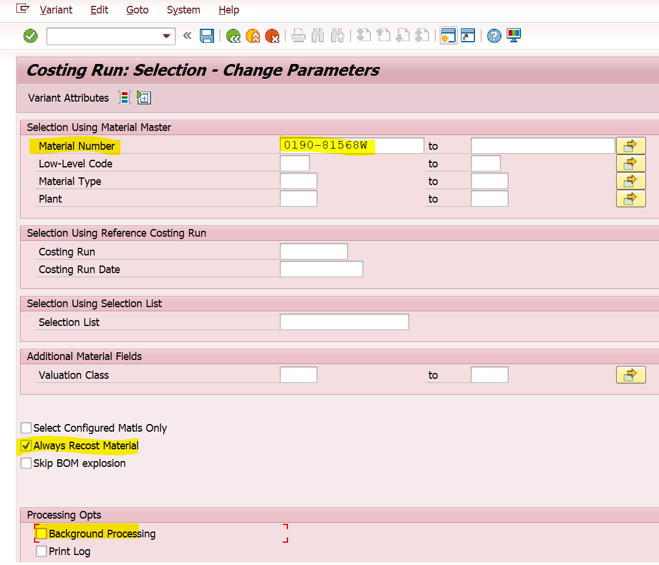
Come back and click on execute
